# Full Name : Siripuram Bhavana

# Contact No. : +918790936980

# Whatsapp No. : +918790936980

# Parents Name and Profession : Laxman (Lecturer) & Jyothi(Homemaker)

# Address : H.NO: 12-45, Vidyanagar, Mandamarri, Mancherial-504231

# College Name : Bhoj Reddy Engineering college for women

# Percentage or CPGA of 10th, 12th and Graduation/Masters : 10th - 87%, 12th - 97% and Graduation - 74%

# College ID or Office ID (image) :

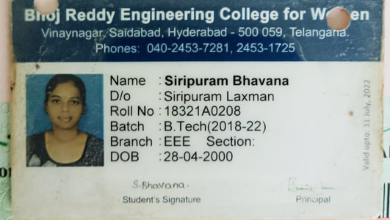

# Address : Vinaynagar, Saidabad, Hyderabad – 500 059

# Passport Size Photo (image) :

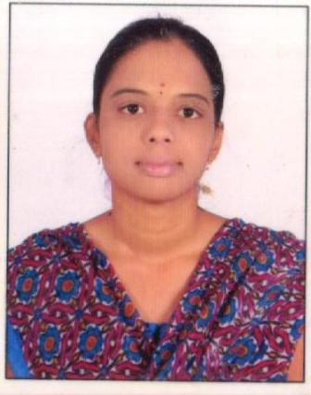

# Screenshot of Payment details (image)

Send these things on [vlsiforallnow@gmail.com](mailto:vlsiforallnow@gmail.com) for registration…